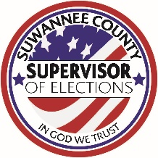
Suwannee County
Jennifer Kinsey Supervisor of Elections

Active Petition Signature Verification Report
Report Date: February 3, 2022
Pursuant to FS 100.371 (11) (c), the Suwannee County Supervisor of Elections provides this monthly report related to the number of petitions received by our office.

Petition Name | Petition Serial Number | Total Petitions Received * | Total Petitions Verified | Total # of Invalid Signatures | Total # of Valid Signatures | Total # Sent to State
Right of Adults to Cannabis | 15-20 | 72 | 72 | 29 | 43 | 72
Regulate Marijuana Manner Similar to Alcohol | 16-02 | 112 | 112 | 37 | 75 | 112
Medicaid Coverage to Eligible Low-Income Adults | 18-16 | 2 | 2 | 0 | 2 | 2
Prohibits Possession of Defined Assault Weapon | 19-01 | 14 | 14 | 6 | 8 | 14
Human Life Protection Amendment | 19-14 | 641 | 641 | 161 | 480 | 641
Authorizes Sports and Events Betting | 21-13 | 261 | 261 | 95 | 166 | 261
Limited Authorization of Casino Gaming | 21-16 | 1,368 | 1,368 | 829 | 539 | 1,368
Legalizes Personal Use Marijuana for Adults 21 or Older, Permits Adults to Cultivate Marijuana | 21-17 | 149 | 149 | 47 | 102 | 149
*Total number of petitions received includes petitions received but not yet processed.

